CSS Matching by text
- <htmltag>:has-text("Playwright")
- The :has-text() matches any element containing specified text somewhere inside, possibly in a child or a descendant element.
- Matching is case-insensitive, trims whitespace and searches for a substring.
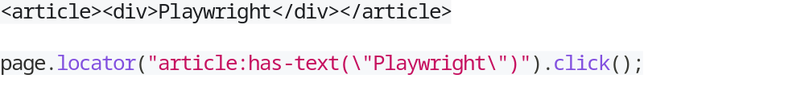

- <htmltag>:text("Home")
- The :text() pseudo-class matches the smallest element containing specified text. Matching is case-insensitive, trims whitespace and searches for a substring.

- <htmltag>:text-is("Home")
- Matches exact text inside an element

- <htmltag>:text-matches("reg?ex", "i")
- Matches with element having particular regx

- Text matching always normalizes whitespace. For example, it turns multiple spaces into one, turns line breaks into spaces and ignores leading and trailing whitespace.
- Input elements of the type button and submit are matched by their value instead of text content. For example, :text("Log in") matches <input type=button value="Log in">.

CSS Matching only visible elements
Like Locator.visible() there is a Playwright pseudo class named :visible.
CSS Elements contain other element
- :has() this method an element inside the parent element
Following snippet returns text content of an <article> element that has a <div class=promo> inside.

CSS Elements matching one of the conditions
Comma-separated list of CSS selectors will match all elements that can be selected by one of the selectors in that list.
CSS pick n-th match from query result
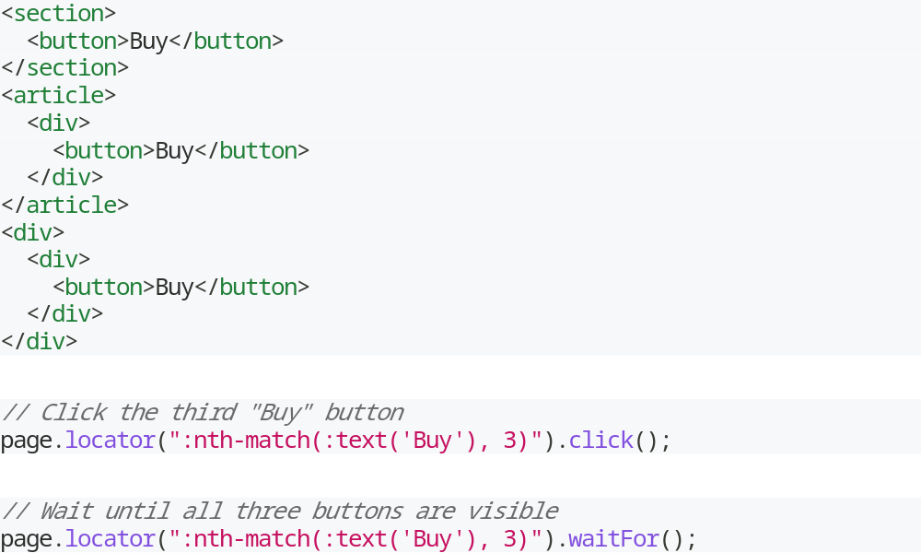

CSS N-th element locator
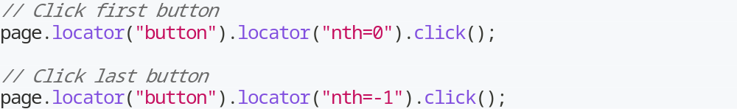

Parent element locator
When you need to target a parent element of some other element, most of the time you should Locator.filter() by the child locator
If you'd like to target the parent <li> of a label with text "Hello", using Locator.filter() works best.
